We thank the referees for their final comments. We have responded to each of the referee comments below. The original comment is preceded by “COMMENT:”, and our response by “RESPONSE:”.

In addition to these changes and those described below, we made several minor changes to the manuscript, as documented throughout, based on feedback from other scientists.

We also slightly modified Figure 13 to compare the advective wind speeds during vortex encounters to wind speeds during the same times of day when vortices are encountered but during hours when vortices were NOT seen. This comparison is a bit better suited than the original comparison (advective wind speeds for vortices vs. all hourly wind speeds).

For clarity, the original Figure 13 looked like this:

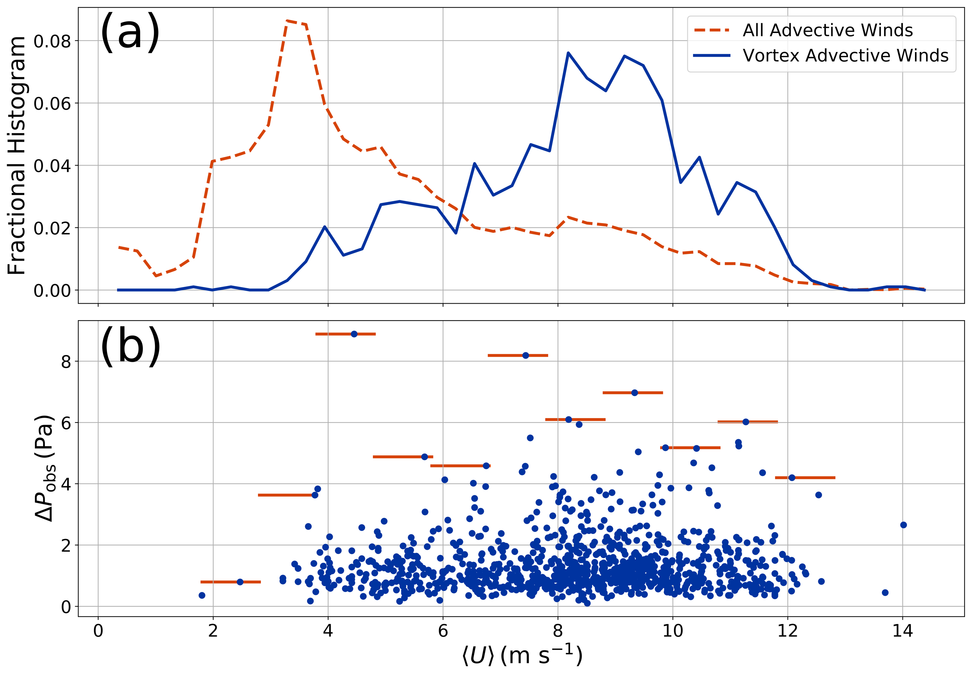

And here’s the new figure:

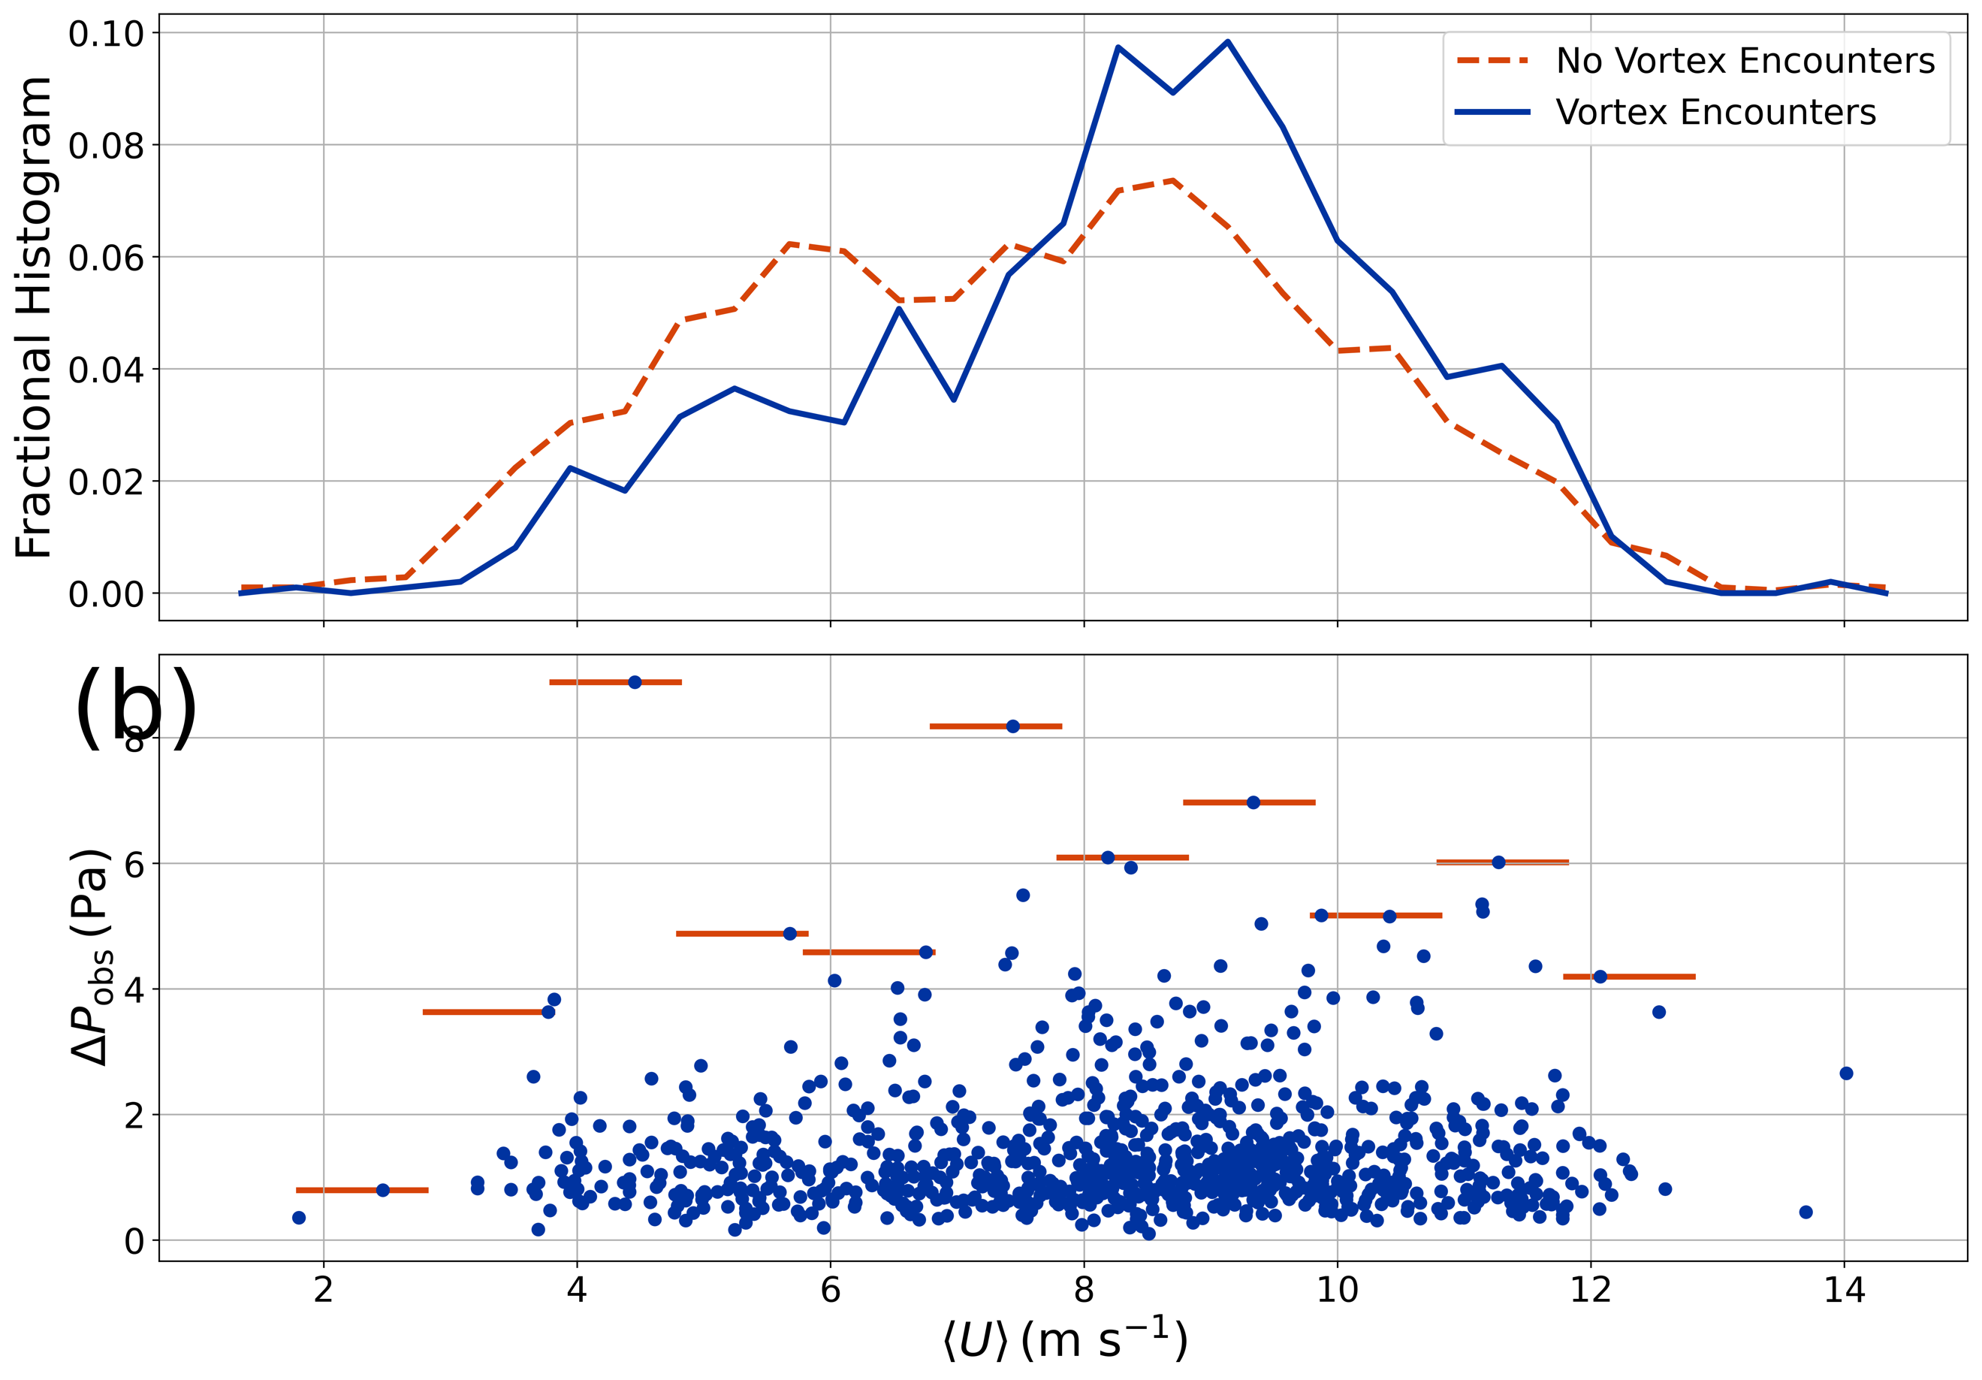

-- Reviewer #1 --

COMMENT: The authors have addressed my critical comments and, as I see, the other Reviewer's comments. As a whole, the manuscript has been noticeably improved and I can recommend it for publication in the Planetary Science Journal. However, I do have a comment on a newly added Section 4.3, which is intended to interpret the absence of detected dust devils in terms of windier conditions at the InSight landing site compared to previous landing sites on Mars. It is true that there is an upper threshold value of ambient wind speed for dust devil activity, as found in terrestrial field campaigns, although this threshold value does not necessarily match that of Mars. However, from my perspective, a more important reason for the lack of detected dust devils may be the deficiency of volatile dust on the Martian surface at the InSight landing site. It could also be taken into account that the threshold value mentioned above refers to the total convective vortex activity, that is, regardless of whether a vortex is dustless or alternatively dust-laden (that is, it is a dust devil).

RESPONSE: We have added the caveat in several places in the manuscript that multiple causes may contribute to suppressing dust devil formation. In addition, we note that a lack of available dust may be partly responsible.

-- Reviewer #2 –

COMMENT: One minor criticism remains: Regarding my (reviewer 2) comment on the original lines 280-281 about the implications of no dust devils in 1000 images, there still appears to be a disconnect. (1) I do not argue with the idea that maybe 1/3 of vortices are dusty. I remain surprised that, if potentially 1/3 of vortices are dusty at InSight and none are seen in images, dust devils would be seen in abundance at any site. One wonders how InSight can be not particularly unusual in this respect. (2) The response goes on to discuss more analysis with respect to dust devils and wind speeds, and argues for the proposition that high winds suppress dust devils. While this argument is well presented, I still am unsure of the relationship between suppression of vortices (which one would suspect as the root cause) and suppression of only dust devils (since InSight has an abundance of one and not the other). In any case, the last two paragraphs of section 4.3 provide adequate context. Additional clarification, if available, would be appreciated, but the discussion is enough to stand on its own.

RESPONSE: We attempt to address this point by making clear in the Discussion that the 35% upper limit is only an upper limit with important limitations and caveats and that the true fraction of dust devils at InSight could actually be smaller.